Link: <http://www.studytonight.com/computer-networks/osi-model-physical-layer>

**Physical Layer**

#### Replace the content before : FUNCTIONS OF SESSION LAYER:

With the following :

The Session Layer allows users on different machines to establish sessions between them.

Its main aim is to establish, maintain and synchronize the interaction between communicating systems. Session layer manages and synchronize the conversation between two different applications. In Session layer, streams of data are marked and are resynchronized properly, so that the ends of the messages are not cut prematurely and data loss is avoided.

Sessions offer various services:

* **Dialog control**: keeping track of whose turn it is to transmit.
* **Token management**: preventing two parties from attempting the same critical operation at the same time.
* **Synchronization**: check pointing long transmissions to allow them to continue from where they were after a crash.

**Design Issues with the Session Layer**

* To allow machines to **establish sessions** between them in a seamless fashion.
* Provide enhanced services to the user.
* To manage dialog control.
* To provide services such as **Token management** and **Synchronization**.

**Replace the given image with this and put it at the end of the page: (Rest of the content is fine and verified)**

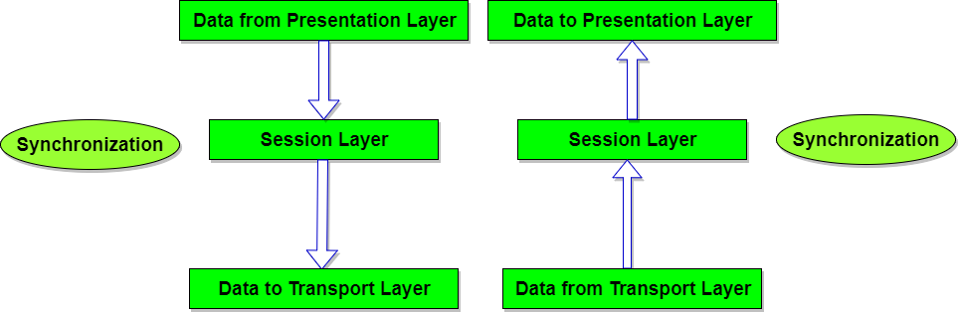

#### Under: FUNCTIONS OF SESSION LAYER:

**Add third function:**

3. **Token Management**: Preventing two parties from attempting the same critical operation at the same time.